*UX FEEDBACK REPORT*

By Tim Verhees  
386482

V1.0

# Visibility of system status

It is important that and application displays it’s status as much as possible. This helps the user understand what is going on. For example when the user presses a button and the website needs to load a little to accommodate the request, it should display some form of loading.

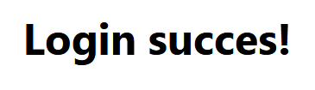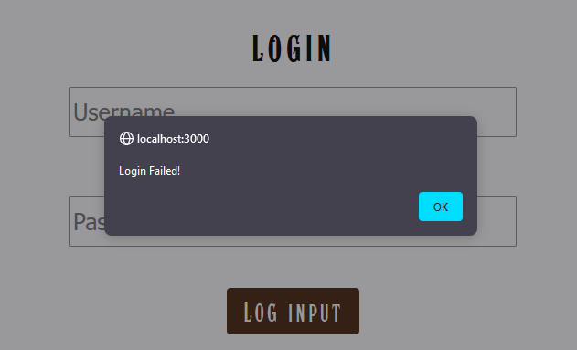Currently my application on supports status updates, meaning that there isn’t too much to load, and so I’ve simply made it so successful and unsuccessful attempts at actions are displayed to give clarity to the user. The following are some examples of this.

Another is attempts at adding images to cards.

Currently I am working on giving successful attempts at other actions like adding cards, signing up and banlist CRUD.

# Match between system and real world

It’s important for the application to feel familiar to the one using it right from the get go. This means it should use icons, language and images that feel inherently familiar to them. Examples of this is like back buttons being arrows and male/female icons being the restroom ones.

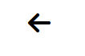In my application the usage of this principle is limited, but it is there.

A simple, straight forward example is the back button used on both the ban list page and the card creation page. This arrow translates to go back, aka backwards to the previous page or element.  
What I aim to improve on in this principle is to make hyperlinks tell what they do. For instance currently to view ones ban list they click the hyperlink matching the name of the ban list. This could be improved by having the name without the hyperlink and a button next to it to view said ban list.

# User control and freedom

No one is perfect, including the end user. But it is important that we can handle errors from said user so that they can have a free experience on the website and not feel constraint by it.

In my case this is through given back arrows to cancel out of whatever they were doing, giving clear indication that; “Hey, it’s okay to go back, you won’t break anything”.

What can be improved in this aspect is a method to log out of the application, giving the user the feeling that they truly have freedom in the application.

# Error prevention

Sometimes things are forgotten or not filled in correctly. It is important the site first of all doesn’t break when this happens, and second it is important that the user understand why what they tried to do didn’t work.

Examples of this are faulty logins, faulty entries to the database and so on.

In my application this is currently shown with simple red messages and alerts telling them that something went wrong and that they should try again. (See examples from principle 1)

What can be improved though is the clarity of the error, being more specific about what exactly was wrong. If the password was wrong but the username was correct it should show that, similarly it should show why adding a card didn’t work.

# Help users recognize, diagnose, and recover from errors.

This principle extends upon the 4th one where, it should be clear what is an error if it occurs and how it be helped now, or in the future. A good example of this is when the user accidentally presses the delete button on something. It shouldn’t instantly delete. It should show a pop up or perhaps options to confirm whether they actually want to delete it.

Currently in my application, something like this isn’t necessary yet, however once deleting cards is implemented, it should be handled accordingly.

# Consistency and standards.

Your application should have a standard across the board when it comes to design and styling. A cluttered website can feel unpleasant to work with and often times confusing in terms of what is real or maybe an ad.

For my website I’ve decided to keep it simple. The navigation bar is a bit flashier in terms of it’s buttons, but the overall theme of the website very much has to do with the colour #b2591a. Which is the main colour I’ve chosen for the website. It returns in the background of the navbar. The buttons on the body of the website. And the background image for the website it very near to it.

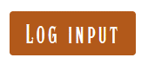Apart from that, to keep with the theme of Yu-Gi-Oh! the font of the website has been greatly inspired by the one used in the show, in an Egyptian style.

What could be improved on this front is consistent sizing. As seen above the buttons are of slightly different size with, slightly different font size. Consistency is key and it is lacking in this aspect.

# Recognition rather than recall.

It’s important that the website is smart enough to recognise the user’s input and works with it to ensure that the user has a better experience. This means that predictive options when the user types something in is a good thing to have and that when given an option to select something, all the options should be clear.

My website will not be employing this principle on a big scale. When adding cards a drop down will appear with options for type and attribute.

# Flexibility and efficiency of use.

If a user is a frequent visitor of the website it shouldn’t be necessary to have the user do the same input over and over again at each visit. Security should be maintained but some information should be able to be remembered.

Luckily most browsers nowadays are able to recognise a login and are able to save this information for the user without any input from the actual website. My application will not take this further than necessary. One thing that could be implemented, but doesn’t have a high priority, is that when adding cards to a ban list, the last used ban list should be the default.

# Aesthetic and minimalist design

A website should be concise in terms of providing options and information for the end user. A minimalist design helps the user navigate through the website with a singular brain cell. A good example of this is modern websites as they really strive to minimalize every aspect of their website.

For my website I aim to achieve this through consistent simple design and a concise view.

# Help and documentation

While it is important that the website should be easy to use and straight forward, there should be help available for users to fall back on in case of confusion.

I will not be employing this principle. The website is simple enough as it is, though in the future with low priority an option for a walkthrough could be provided.

# User feedback

For actual user feedback I had some fellow students go through my website. This is their feedback:

Tom’s feedback:

**Observations:**

* Buttons need to be nicer and have a dedicated spot on the website.
* Banlist segments should be centered before featuring the cards.
* A filtering option for the cards should be made.
* Card page itself does look good.

**What will be done?**

* The dev buttons will be deleted from the website and the ones that will be added in the future will be compliant to the overall design.
* This will be done.
* A filtering option is pretty far down my list of priority but it could be seen as technical debt as it is part of my vision.
* Thank you 😊

Saeed’s feedback:

**Observations:**

* Buttons need to give feedback upon press
* Password should display dots instead of the actual value.
* Buttons on card page need to be moved

**What will be done?**

* This is in the process but every button will give status updates upon it’s press.
* It does now.
* These will be removed and replaced.